CRM APPLICATION THAT HELPS TO BOOK A VISA SLOT

INTRODUCTION:-

A visa slot management project is a system that is used to track and manage the availability of visa slots, which are appointments that are required for certain visa applications. It might be used by a government agency or a visa processing center to schedule and manage appointments with applicants.

OVERVIEW:-

A CRM system manage all your contacts and aggregates lead and customer information to build profiles of every one with. this gives easy access to important information to better understand customer behavior like purchase record and previous communication with contact across different channels (chat,email…..)

PURPOSE:-

Four CRM applications that helps to book a visa slot, a visa slot management project is a system that is used to track and manage the availability of visa slots ,which are appointments that are required for certain visa applications.

PROBLEM DEFINITION AND DESIGN THINKING :- IDEATION AND BRAINSTOMING :-

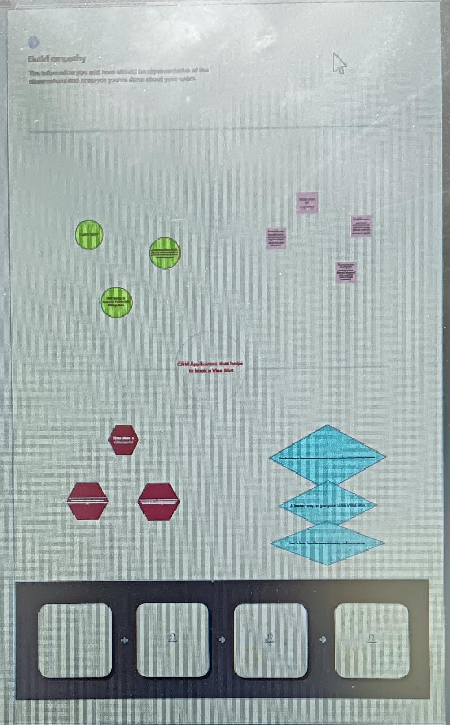EMPATHY MAP:-

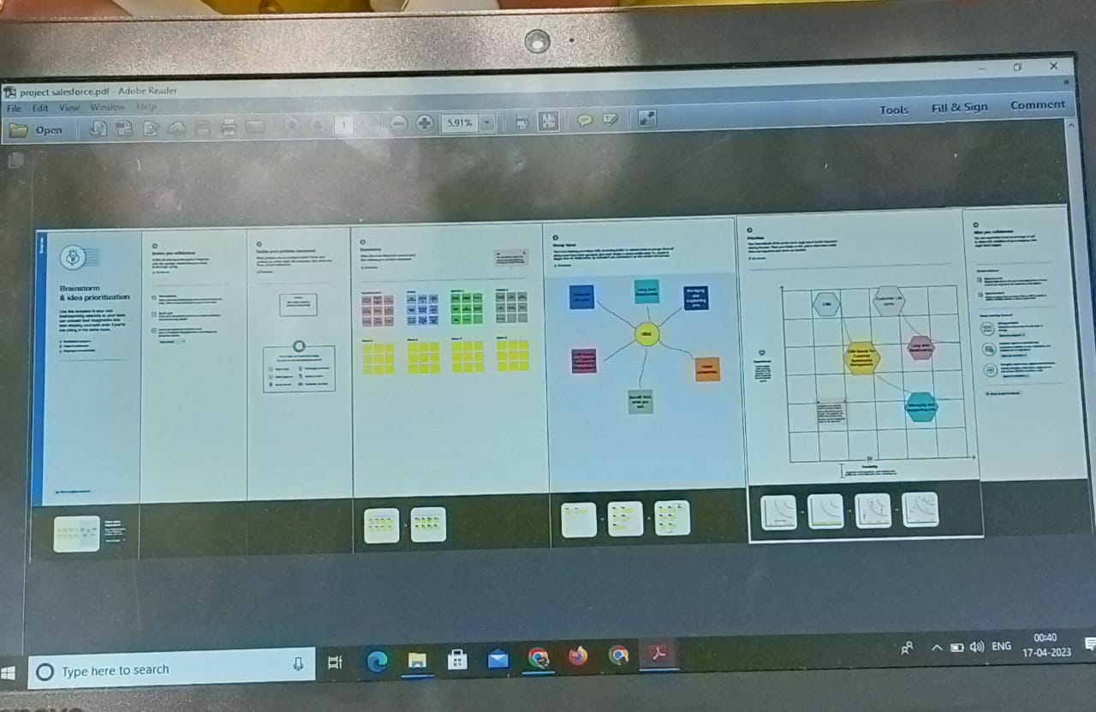

3. RESULT:- 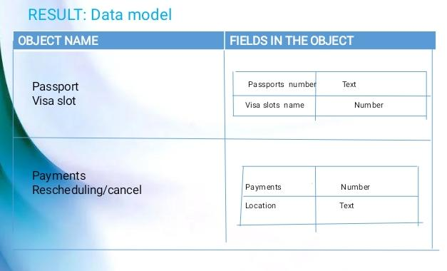

ACTIVITY AND SCREENSHOTS:-

1. CREATION OF SALESFORCE PLATFORM:-

Go to salesforce.com and click on sign up. Enter our detail as Name,Email ,role, Company etc email is received to your email id

Go to inbox of the email that you used while signing up. click on the verify account to activate your account

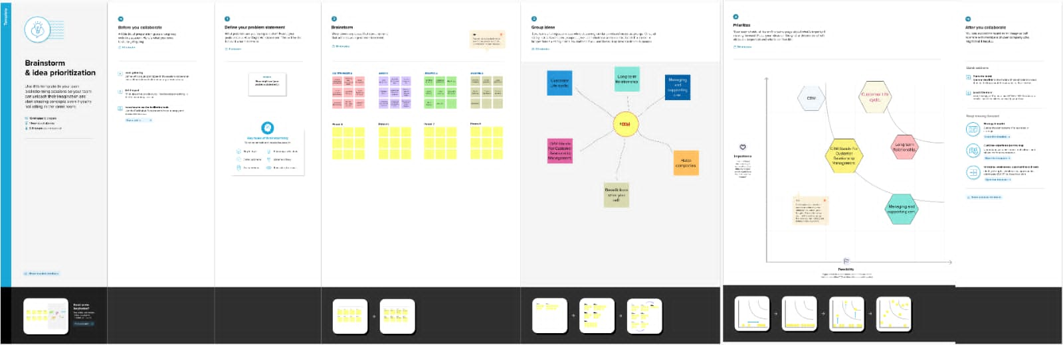

MILESTONE 1:-

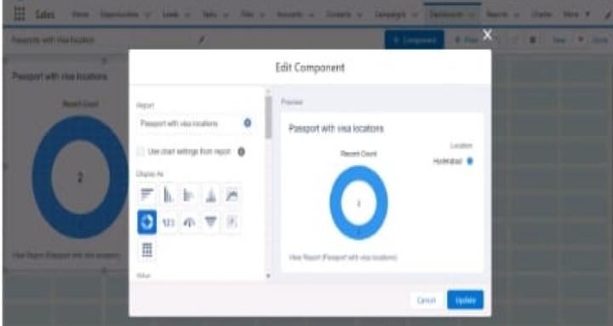

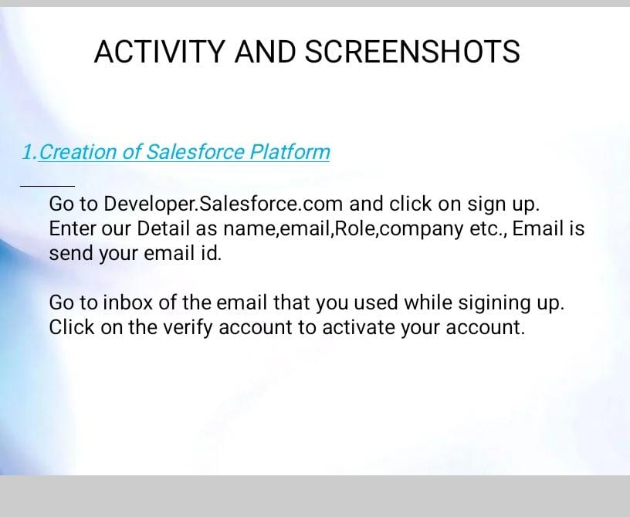

MILESTONE 2:-

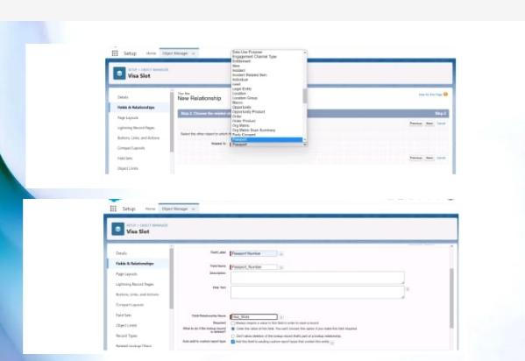

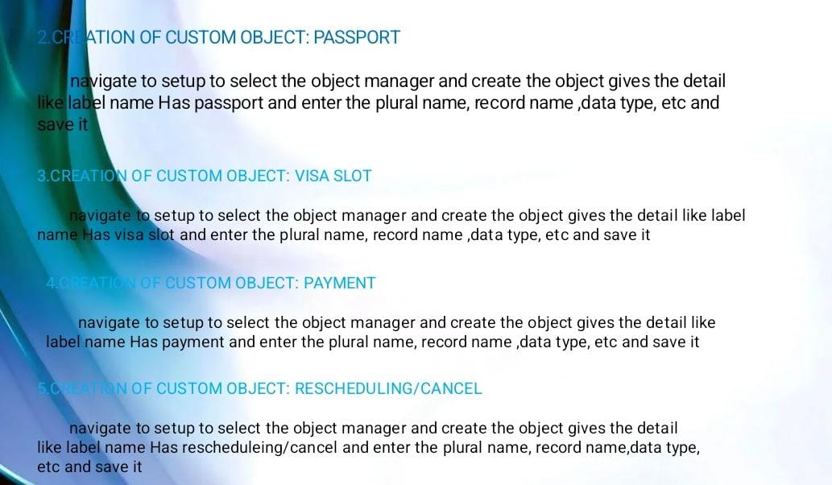

MILESTONE 3:-

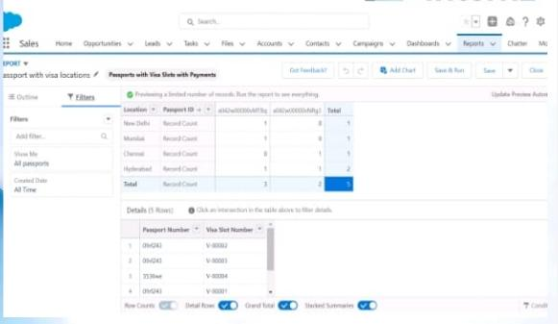

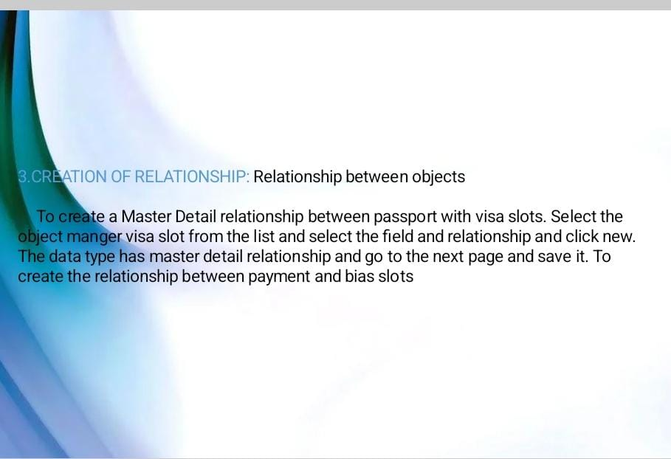

MILESTONE 4:-

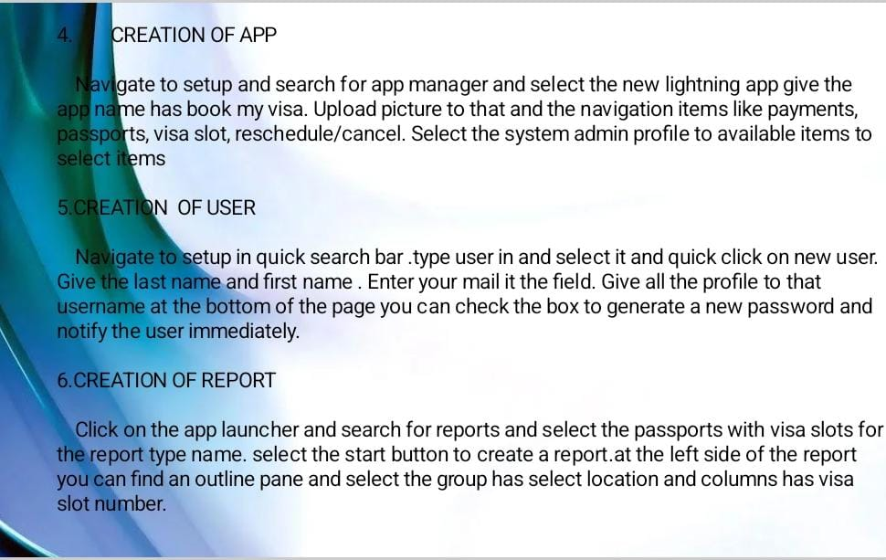

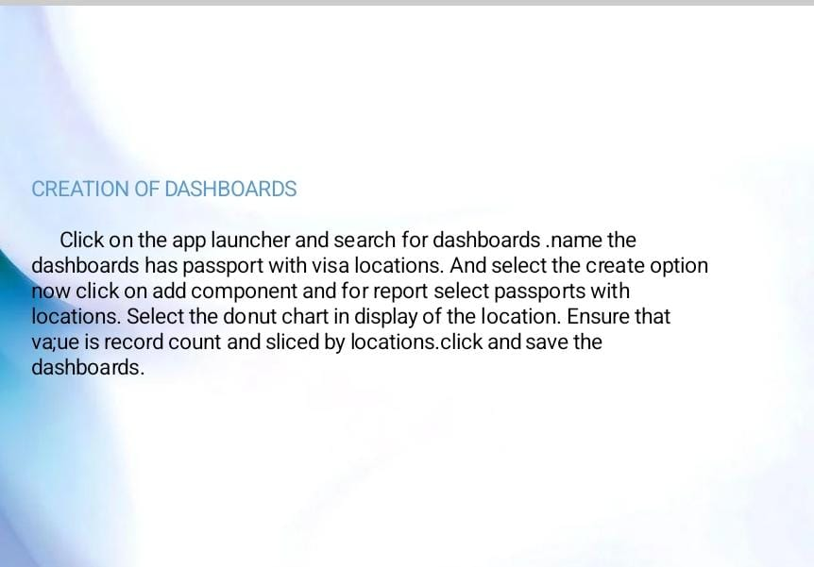

4. TRIALHEAD PROFILE PUBLIC:-

Team lead:- <https://trialblazer.me/id/jasminesyed>

Team member 1:- https://trialblazer.me/id/hgahlot3

Team member 2:- https://trialblazer.me/id/iswarya15

Team member 3: -https://trialbblazer.me/id/jsrinivasan16

ADVANDATAGES & DISADVANTAGES :-

ADVANTAGES OF CRM

1* It allows for more effective sales and marketing.

2* It can speed up the sales conversion process.

3* It increases staff productivity , lowers time costs and boost morale.

DISADVANTAGES OF CRM:

1* Staff over reliance on CRM may diminish customer loyalty through a bad experience.

2* Security concerns associated with centralized data.

3* The excess initial time and productivity cost of implementation.

4* It requires a process driven sales organisation .

5* It may not suit every business.

APPLICATIONS:-

Application 1: Tracking Customers.

Application 2: Collecting Data for Marketing.

Application 3: Improving Interactions and Communications.

Application 4: Streamlining Internal Sales Processes

Conclusion:-

Customer Relationship Management enables a company to align its strategy with the needs of the customer in order to best meet those needs and thus ensure long-term customer loyalty. However, in order to be successful in these aims, the different company departments have to work together and use measures in a coordinated fashion. This purpose is achieved via a customer database which is analyzed and updated using CRM software.

FUTURE SCOPE:-

This approach will be of particular interest to companies operating in highly competitive markets where it is difficult to attract new customers.

Understanding the CRM scope you hope to achieve is crucial to the success of your CRM implementation. “Scope” refers to how far-reaching the CRM will be within your organization. For example, if only your customer service reps will be using it, the scope of your CRM would be considered narrow. If your marketing teams, sales reps, customer care team, data analysts and project managers will all be utilizing the system, that is a broad scope of CRM.

|  |
| --- |
|  |

|  |  |
| --- | --- |
|  |  |
|  |

|  |  |  |
| --- | --- | --- |
| |  |  | | --- | --- | | |  | | --- | | https://mail.google.com/mail/u/0/images/cleardot.gif | | |
|  |
|  |